**Ideation Phase**

**Define the Problem Statements**

| Date | 26 June 2025 |
| --- | --- |
| Team ID | LTVIP2025TMID32174 |
| Project Name | EduTutor AI: Personalized Learning with Generative AI and LMS Integration |
| Maximum Marks | 2 Marks |

**Customer Problem Statement EduTutor AI:**

Students who study independently often struggle to evaluate their understanding of complex subjects due to a lack of instant, customized quizzes and feedback. This leads to inefficient revision, reduced confidence, and missed learning opportunities. EduTutor AI solves this by allowing students to instantly generate quizzes from any subject , evaluate answers, and track their performance — enabling smarter, more confident learning.

EduTutor AI aims to solve this by offering a personalized AI tutor that provides:

* Concept explanations simplified for different age levels
* Grammar and language learning support in English and Hindi
* Automated quiz and test generation from PDFs and topics

This solution empowers students to learn at their own pace with clarity, and enables educators to scale personalized learning experiences without increased workload.

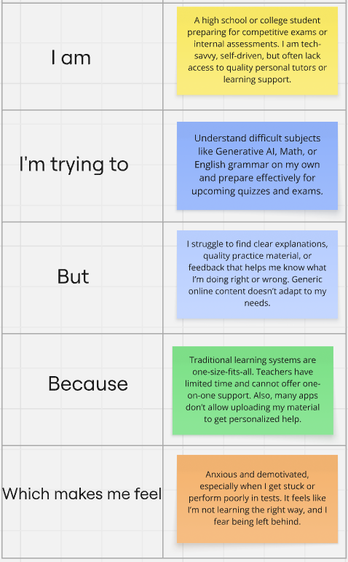

**Example:**

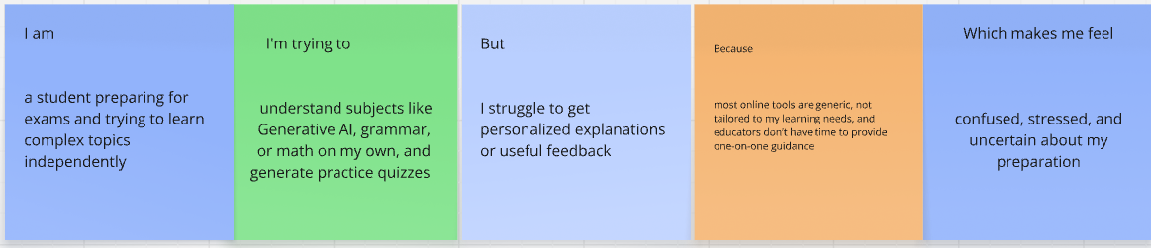

| **Problem Statement (PS)** | **I am (Customer)** | **I’m trying to** | **But** | **Because** | **Which makes me feel** |
| --- | --- | --- | --- | --- | --- |
| PS-1 | a self-learning student preparing for exams. | assess my understanding of topics by practicing questions | I don’t have access to quick, customized quizzes for the material I’m studying | manually creating practice questions from textbooks or PDFs is time-consuming and difficult | overwhelmed, unsure about my progress, and anxious about my preparation. |
| PS-2 | a college student revising from my classroom notes and e-books | generate quizzes and test myself on what I just studied | I can’t instantly convert my study materials into quizzes or evaluate myself easily. | existing tools are not personalized or don’t support input from PDFs. | frustrated, less confident, and disconnected from my learning goals |